POLAR VS. NON POLAR
Remember my students the ice cream I always talk about?? What is polarity?
To be polar you will have to have two opposite charges, a negative and a positive. And one will have to be more electronegative than the other, causing a pull. The bond is always going to be covalent! But there is covalent polar and covalent non-polar. Diatomic molecules are not polar because they have the same electronegativity so the charge cancels its self out.
When is a LEWIS STRUCTURE molecule POLAR?
- WHEN YOU HAVE LONE PAIR OF ELECTRONS

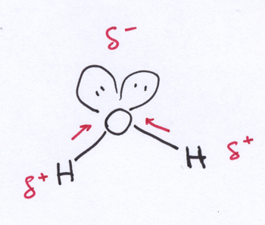

- WHEN AT LEAST ONE OF THE ATOMS SURROUNDING THE CENTER IS DIFFERENT

SO CH4 is NOT polar, because it is surrounded by the same element!! But CCl2F2 is!!! Makes sense!

Please answer the following practice sheet and determine if polar or nonpolar!!!

P.S A REMINDER DIATOMIC ATOMS ARE NOT POLAR BECAUSE the charge cancels out .

